A Project Report on

Stylora
By
Chaitanya Milind Chavan
(Roll No - 20250202016)
MCA – I, SEM – II
2025-26

To
Savitribai Phule Pune University, Pune

In Partial Fulfillment of the Degree of
Master in Computer Application (M. C. A.)

Under The Guidance Of
Prof. Anagha Sawant

Suryadatta Group of Institutes, Pune
Suryadatta Institute of Business Management & Technology -SIBMT

Date:-
CERTIFICATE
This is to certify that Mr. Chaitanya Milind Chavan has successfully completed their project work entitled “Stylora” in partial fulfillment of MCA – I Semester-program for the year A.Y. 2025-26. They have worked under our guidance and direction.

Prof. Anagha Sawant Dr. Manisha Kumbhar
Project Guide Professor & Director (SIBMT)

Examiner 1 Examiner 2

Date :
Place :

Acknowledgment
I am the student of MCA first year. Here by I express my thanks to our project guide for allowing us to do the project on “Stylora”. This project work has been the most exciting part of our learning experience which would be an asset for our future carrier. We would especially like to thank our guide and mentor Prof. Anagha Sawant, who constantly guided me in developing, pushing me to search for more answers to her numerous questions. Also I would like to thank Prof. Apurva Patil, project coordinators for their support. As a building block of MCA Department, I thank Dr. Manisha Kumbhar, Professor & Director, SIBMT for her continuous support and help. I am grateful to many classmates who contributed their suggestions. Their hard work and examples push us to limits of our capability and encourage us daily.

Thank You,
Chaitanya Milind Chavan
(SIBMT, Div. – A, Roll No - 20250202016)

Index
Chapters | Page No
CHAPTER 1: INTRODUCTION
1.1 Existing System
1.2 Need for System
1.3 Operating Environment (Hardware and Software)
1.4 Brief Description about Technology Used
CHAPTER 2: PROPOSED SYSTEM
2.1 Proposed System (Introduction of system)
2.2 Module Specifications (Scope)
2.3 Objectives of System
CHAPTER 3: ANALYSIS & DESIGN
3.1 Use Case Diagram
3.2 Activity Diagram
3.3. Sequence Diagram
3.4 Class Diagram
3.5 Module Hierarchy Diagram
3.6 Table Specifications (Database Design)
3.7 Data Dictionary
CHAPTER 4: USER MANUAL
4.1 User Interface Screens (Input)
4.2 Output Screens with data
4.3 Data Reports
4.4 Sample program code
4.5 Limitations
Bibliography

CHAPTER 1: INTRODUCTION

1.0 Introduction

Due to the rapid expansion of digital technologies and internet services, professionals are increasingly utilising the internet for displaying their work and reaching potential clients. For interior design professionals, it is essential to have a strong presence on the internet for displaying their creativity and reaching new clients. However, it is often hard for clients to find suitable interior designers according to their tastes, budgets, and requirements.

Stylora is a web-based application designed for bridging the gap between interior designers and clients. Stylora is designed for interior designers who can create visually attractive web pages for displaying their work and abilities. Clients can easily find suitable interior designers based on different criteria such as style, location, and budget.

Stylora is designed for facilitating communication between interior designers and clients. Clients can easily schedule appointments with interior designers using Stylora. Additionally, email notifications are sent to designers and clients for ensuring a highly organized interaction process. Stylora is built using modern technologies and frameworks such as Django, Python, and PostgreSQL for creating a highly responsive and efficient environment for interior designers and clients.

1.1 Existing System
In the current scenario, interior designers are able to reach potential customers and promote themselves through:
• Social media sites like Instagram, Pinterest, and Facebook, where they showcase their work.
• Personal websites, which are hard to find unless promoted properly.
• Referrals, where customers get to know the designer through word of mouth.
This is where the discovery and communication process is not efficient, as there is no platform where the customer can easily search and get in touch with the designer based on their requirements.
Most existing systems suffer from the following limitations:

1. Lack of a Dedicated Platform for Interior Designers

Currently, interior designers mostly use general platforms such as social media, personal websites, and other third-party portfolio websites. These platforms are not specifically designed for interior design services, and it becomes difficult for them to present their work in a structured and professional way. They are not able to categorize their work according to style, type, and budget, and it becomes difficult for them to showcase their work and attract suitable clients.

2. Difficulty in Finding Suitable Designers

The clients usually face difficulties in finding designers that suit their particular needs and preferences, such as design style, location, project types, and budgets. However, the current platforms do not offer an efficient way of filtering, making the process time-consuming and less effective.

3. Inefficient Communication Process

Communication between designers and clients is mostly done through emails, phone calls, and social media messages. This is an unstructured process and may lead to delays and difficulties in scheduling consultation.

4. Lack of Structured Portfolio Management

Many designers tend to showcase their designs using social media or unorganized websites. These websites cannot categorize the designs, and this may not help the client to know what the designer is capable of.

5. Limited Platform Management

In the conventional systems, there is no facility of having a centralized admin control panel. This becomes difficult while monitoring and managing the users, portfolios, and activities on the platform.

As the conventional systems are limited, there are difficulties faced by the designers as well as the clients.

1.2 Need for the System

1.2 Need for the System

The development of the Stylora platform is necessary to address several challenges faced by both interior designers and clients in the current digital environment.

1.2.1 Creating a Dedicated Platform for Interior Designers

Interior designers often rely on social media or general portfolio websites to showcase their work.

• The Problem: These platforms are not specifically designed for interior design portfolios, making it difficult for designers to organise projects and for clients to discover suitable professionals.

• The Solution: Stylora provides a specialised platform where designers can create structured portfolios that highlight their projects, design styles, and expertise professionally.

1.2.2 Simplifying Designer Discovery for Clients

Finding the right interior designer can be a complex process for clients.

• The Problem: Clients usually need to browse multiple websites or social media profiles to find designers that match their preferences, which is time-consuming and inefficient.

• The Solution: Stylora introduces a smart filter-based search system that allows clients to easily find designers based on factors such as design style, location, project type, and budget.

1.2.3 Streamlining Communication Through Appointment Booking

Communication between designers and clients is often unstructured and difficult to manage.

• The Problem: Scheduling consultations typically requires multiple phone calls, emails, or messages, which can lead to delays and confusion.

• The Solution: Stylora integrates an appointment booking system where clients can schedule consultations directly through the platform, with automatic email confirmations sent to both parties.

1.2.4 Centralised Portfolio and Platform Management

Managing portfolios and platform activities can be difficult without proper administrative tools.

• The Problem: Designers often lack a single platform to manage their portfolios efficiently, and administrators cannot easily monitor user activities.

• The Solution: Stylora includes a centralised admin panel and role-based dashboards that allow administrators to manage users, portfolios, and platform categories, while designers can easily update and maintain their project showcases.

1.2.5 Secure Authentication and Role-Based Access

Security is an important aspect of any online platform.

• The Problem: Without proper authentication and access control, platforms are vulnerable to unauthorised access and misuse of data.

• The Solution: Stylora implements secure login systems with role-based access control for designers, clients, and administrators, ensuring that each user only has access to relevant features and data.

1.2.6 Scalability and Automation
The choice of the MERN stack (MongoDB, Express, React, Node) ensures the platform can grow.
- Database Scalability: MongoDB is "Schema-less," meaning if you decide to add new features (like "Product Reviews" or "Video Recipes") later, you can do so without breaking your existing database structure.
- Automated Workflow: From the moment a user clicks "Pay" to the generation of a PDF Invoice via PDFKit, the system minimizes manual data entry. This allows the business owner to focus on sourcing products rather than managing paperwork.

Thus, Stylora fulfills the need for a centralized digital platform that helps interior designers build their professional presence while enabling clients to easily discover and connect with the right design professionals.

1.3 Operating Environment (Hardware and Software)
The operating environment defines the hardware and software requirements needed to run the system efficiently.

1.3.1 Hardware Requirements
- Processor: Intel i3 or higher
Required to handle frontend rendering, backend processing, and database operations.
- RAM: Minimum 8 GB
Ensures smooth multitasking during development and execution of the application.
- Storage: Minimum 256 GB SSD
Required for storing application files, databases, and logs.
- Internet Connection:
Necessary for API communication, payment gateway integration, and cloud services.

1.3.2 Software Requirements

Frontend Environment
- Operating System: Windows / Linux / macOS
- Web Browser: Google Chrome, Mozilla Firefox, Microsoft Edge
- Framework: React.js
- Build Tool: Vite
- Styling Framework: Tailwind CSS
- Language: JavaScript (ES Modules)
The frontend provides an interactive and responsive user interface for browsing products, reading recipes, and placing orders.

Backend Environment
- Runtime Environment: Node.js
- Framework: Express.js
- Database: MongoDB
- Authentication: JWT
The backend handles business logic, API requests, database communication, authentication, and payment processing.

1.4 Brief Description of Technology Used

1.4.1 React.js
React.js is a JavaScript library used for building dynamic and responsive user interfaces. It follows a component-based architecture, making the application modular, reusable, and easy to maintain. React improves performance using a virtual DOM, which updates only the necessary components instead of reloading the entire page.

1.4.2 Vite
Vite is a modern frontend build tool that provides fast development startup and optimized production builds. It improves developer productivity by enabling hot module replacement and faster compilation compared to traditional bundlers.

1.4.3 Node.js
Node.js is a server-side JavaScript runtime environment that allows the application to handle multiple requests asynchronously. It is highly scalable and suitable for building real-time and data-intensive applications like e-commerce platforms.

1.4.4 Express.js
Express.js is a lightweight and flexible Node.js framework used to develop RESTful APIs. It simplifies routing, middleware integration, and request handling, making backend development efficient and structured.

1.4.5 JavaScript
JavaScript isn't just for browsers anymore. Over the last decade, it has expanded into almost every area of tech:

Frontend (The Browser)
Libraries and frameworks make building complex apps faster:
- React: Created by Meta, great for building interactive UIs.
- Vue & Angular: Other heavy hitters used for "Single Page Applications."

Backend (The Server)
- Node.js: This allowed developers to use JavaScript to write server-side code. Now, you can build an entire app—front to back—using just one language.

Mobile & Desktop
- React Native: Lets you build real mobile apps for iOS and Android using JS.
- Electron: Powers desktop apps like Discord, VS Code, and Slack.

1.4.6 MongoDB
MongoDB is a NoSQL database that stores data in a flexible, JSON-like format. It is used to store user details, product information, recipes, orders, and payment records. MongoDB supports scalability and high performance.

1.4.7 JWT (JSON Web Token)
JWT is used for secure authentication and authorization. After successful login, a token is generated and sent to the client. This token is used to verify user identity and enforce role-based access control throughout the application.

1.4.8 Cloudinary
Cloudinary is a cloud-based media management service used to store and manage product and recipe images. It provides fast image delivery, optimisation, and secure storage.

CHAPTER 2: PROPOSED SYSTEM

2.0 Introduction
The proposed system, Stylora, is a web-based platform designed to connect interior designers with potential clients through a structured and user-friendly digital environment. The system aims to eliminate the limitations of traditional methods where designers rely on social media or personal references to showcase their work, and clients struggle to find suitable designers based on their requirements.
Stylora provides a centralised platform where interior designers can create professional portfolios to display their projects, skills, and design expertise. Clients can browse these portfolios and use advanced filtering options such as design style, location, and budget to identify designers that match their preferences. This significantly improves the discovery process and reduces the time required to find the right professional.
The system also integrates an appointment booking feature that allows clients to schedule consultations directly with designers. This eliminates the need for unstructured communication through calls or messages and ensures a smooth and organised interaction process. Once an appointment is booked, the system sends confirmation notifications to both the client and the designer, ensuring transparency and reliability.
Stylora follows a role-based architecture, where different users, such as clients, designers, and administrators, have access to specific functionalities. Designers can manage their portfolios and appointments, clients can search and book consultations, and administrators can monitor and manage the overall platform.
The system is developed using modern web technologies, ensuring high performance, scalability, and responsiveness. It is designed to provide an intuitive user experience while maintaining data security and efficient system operations. Overall, Stylora serves as a comprehensive digital solution that bridges the gap between interior designers and clients, enhancing both visibility for designers and accessibility for users.

2.1 Proposed System (Introduction of System)

The proposed Stylora system introduces a specialized digital platform designed to connect interior designers with potential clients through a structured portfolio-based system. Unlike general platforms where designers showcase their work informally through social media, Stylora provides a professional environment where designers can present their projects in an organized and visually appealing way. The platform focuses on improving the discoverability of designers and simplifying the process for clients to find professionals that match their requirements.

Stylora integrates several modern features such as portfolio management, smart search filters, appointment booking, and role-based dashboards for designers, clients, and administrators. These features help streamline the interaction between designers and clients while ensuring efficient platform management. The system is built using modern web technologies such as React js, Node js, Express js and Mongo DB ensuring high performance, scalability, and a responsive user experience across different devices.

Key Features of the Proposed System

1. Designer Portfolio Showcase

The Designer Portfolio Showcase feature allows interior designers to present their work in a professional and structured manner. Designers can upload multiple projects and organize them in categories based on design style, project type, or theme. Each project can include detailed descriptions, images, and information about the design concept, materials used, and overall aesthetic approach. This helps designers effectively communicate their creativity and expertise to potential clients.

This feature also improves the credibility and professional presence of designers by providing them with a dedicated space to display their work instead of relying on scattered social media posts. Clients visiting the platform can easily browse through portfolios and understand the designer’s design philosophy, experience, and previous work. By presenting projects in a visually appealing and organized format, the platform helps designers attract the right audience and build a strong digital identity.

2. Smart Filter-Based Designer Search

The Smart Filter-Based Designer Search feature enables clients to quickly find interior designers that match their preferences and project requirements. Instead of manually browsing through multiple portfolios, clients can apply filters such as design style, location, project type, and budget range to narrow down their search results. This makes the discovery process more efficient and user-friendly.

The filtering system helps users find designers whose expertise aligns with their needs, whether they are looking for modern, traditional, minimalist, or luxury interior designs. By providing a structured search mechanism, the platform saves time for users and improves the overall experience of finding the right professional. This feature also benefits designers because it connects them with clients who are specifically interested in their style or specialization, increasing the chances of meaningful collaborations.

3. Appointment Booking System

The Appointment Booking System is designed to simplify the communication and scheduling process between clients and interior designers. Instead of relying on phone calls or emails to schedule meetings, clients can directly book consultation appointments through the platform. The system allows users to select available time slots and submit booking requests easily.

Once an appointment is scheduled, the system automatically sends confirmation emails to both the client and the designer, ensuring that both parties are informed about the booking details. This feature helps reduce scheduling conflicts and eliminates the need for multiple back-and-forth messages. By providing a structured appointment management system, Stylora makes the consultation process more organized and convenient for both designers and clients, improving overall efficiency and user satisfaction.

4. Secure User Authentication

Security is an important aspect of any digital platform, especially one that manages user profiles and appointments. Stylora includes a secure user authentication system that ensures only authorized users can access specific features of the platform. Users must register and log in before accessing personalized functionalities such as portfolio management or appointment booking.

The platform also supports role-based access control, which means different users have different permissions depending on their role. Designers can manage their portfolios and view appointment requests, while clients can search designers and book consultations. Administrators have additional privileges to manage platform activities and monitor user interactions. This security mechanism protects user data, prevents unauthorized access, and ensures that the platform operates in a safe and controlled environment.

5. User Dashboard

The User Dashboard provides a personalized interface for users to manage their activities on the platform. Once logged in, designers and clients are directed to their respective dashboards where they can access relevant features and information. Designers can upload new projects, update existing portfolios, manage appointment requests, and review their profile information.

Clients, on the other hand, can browse designers, track their booked appointments, and manage their profile details. The dashboard acts as a centralized workspace where users can easily perform all their actions without navigating through multiple pages. By providing a structured and organized interface, the user dashboard enhances usability and helps users interact with the platform more efficiently.

6. Admin Dashboard

The Admin Dashboard is a centralized control system that allows administrators to manage and monitor the overall operations of the Stylora platform. Through this dashboard, administrators can oversee user registrations, manage designer profiles, and monitor platform activities to ensure smooth functioning.

Administrators also have the authority to manage categories, review portfolios, and maintain the overall quality of the content available on the platform. This centralised management system helps maintain the platform's reliability and integrity while ensuring that users follow appropriate guidelines. By providing administrative tools and monitoring capabilities, the admin dashboard helps maintain order, security, and efficient operation of the entire system.

7. Responsive and Modern Interface

Stylora is designed with a responsive and modern user interface to ensure a smooth browsing experience across different devices. The platform automatically adapts its layout and functionality based on the screen size, allowing users to access it from desktops, tablets, or smartphones without any usability issues.

The interface is developed using modern frontend technologies that provide a clean design, easy navigation, and visually appealing layouts. A responsive design ensures that images, portfolios, and interactive elements load correctly on all devices. This enhances user engagement and ensures that both designers and clients can access the platform conveniently anytime and from anywhere. A well-designed interface also improves user satisfaction and encourages users to spend more time exploring the platform.

2.2 Module Specifications (Scope)

The Stylora system is designed using a modular architecture where each module performs a specific set of functionalities. This modular approach improves system maintainability, scalability, and ease of development. The system is divided into the following core modules:

2.2.1 User Management Module

This module is responsible for managing all user-related operations in the system. It handles registration, authentication, authorization, and profile management for clients, designers, and administrators.

Key Functionalities:

New user registration with validation

Secure login using credentials (email/password)

Role-based access control (Client, Designer, Admin)

Session management after authentication

Profile management (view/update personal details)

Logout functionality

Working Process:

User registers by providing required details.

System validates and stores user data securely.

During login, credentials are verified by the backend.

Upon successful authentication, access is granted based on role.

Relevant Model: User

Attributes: id, name, email, password, role, phone, created_at

Ensures secure storage of user credentials and identity

2.2.2 Designer Profile Module

This module is specifically designed for interior designers to create and manage their professional profiles.

Key Functionalities:

Create and update designer profile

Add specialization (e.g., modern, traditional, minimalistic)

Add years of experience

Specify location and service areas

Write portfolio description

Working Process:

Designer logs into the system.

Designer creates or updates profile details.

Information is stored and displayed to clients.

Relevant Model: DesignerProfile

Attributes: id, user_id, specialization, experience, location, portfolio_description

Linked to User table through foreign key

2.2.3 Portfolio Management Module

This module allows designers to showcase their design work through structured portfolios.

Key Functionalities:

Upload multiple project images

Add project title and detailed descriptions

Categorize projects (modern, luxury, minimal, etc.)

Edit or delete existing portfolio entries

Display portfolio to clients

Working Process:

Designer uploads project details and images.

System stores portfolio data in database.

Clients can view portfolios while browsing designers.

Relevant Model: Portfolio

Attributes: id, designer_id, project_title, project_description, image_url, category, created_at

Maintains structured project data

2.2.4 Appointment Management Module

This module facilitates interaction between clients and designers through appointment booking.

Key Functionalities:

Book appointments with selected designers

Select preferred date and time

View appointment history

Manage appointment status (pending, confirmed, cancelled)

Send confirmation notifications

Working Process:

Client selects a designer and clicks “Book Appointment”.

Client chooses date and time.

System stores booking details in database.

Confirmation is sent to both client and designer.

Relevant Model: Appointment

Attributes: id, client_id, designer_id, appointment_date, appointment_time, status, created_at

Tracks all consultation interactions

2.2.5 Admin Management Module

This module provides centralized control over the entire system and ensures smooth functioning of the platform.

Key Functionalities:

View and manage all registered users

Monitor designer profiles and portfolios

Manage platform categories and content

Monitor appointments and user activities

Maintain system integrity and security

Working Process:

Admin logs into the admin dashboard.

Admin views system data and activities.

Admin performs operations such as updating or removing records.

System updates database accordingly.

Relevant Model: Admin

Attributes: id, username, email, password, role

Provides privileged access to system operations

2.3 Objectives of the System

The primary objectives of the Stylora system are as follows:

1. To Develop a Dedicated Platform for Interior Designers

The main objective of the Stylora system is to develop a specialized digital platform exclusively designed for interior designers to showcase their work. Currently, many designers rely on social media platforms or personal websites to display their projects, which often lack proper organization and professional presentation. Stylora aims to provide a structured platform where designers can create detailed portfolios, present their projects, and highlight their design expertise in a visually appealing manner.

By providing a centralized platform, Stylora helps designers build a strong professional identity and reach a wider audience. Clients can easily explore portfolios without navigating multiple websites or social media pages. This objective ensures that designers have a dedicated space to present their creativity while improving their visibility in the competitive interior design industry.

2. To Simplify the Process of Finding Interior Designers

Another important objective of the system is to make it easier for clients to discover and connect with interior designers who match their preferences. In traditional systems, clients often struggle to find suitable designers because portfolios are scattered across different platforms and are not easily searchable.

Stylora solves this problem by providing a smart filter-based search system where users can search designers based on criteria such as design style, location, project type, and budget. This structured search mechanism allows clients to quickly identify professionals whose work aligns with their needs. By simplifying the discovery process, the platform improves user convenience and increases the chances of successful collaboration between designers and clients.

3. To Provide a Structured Portfolio Management System

Stylora aims to provide designers with a structured system for managing their portfolios and design projects. Instead of uploading random images on social media platforms, designers can organize their projects with proper descriptions, categories, and visual presentations.

This feature allows designers to maintain a well-organized portfolio that clearly reflects their experience, creativity, and professional capabilities. Clients can easily understand the designer’s style, previous projects, and design approach. A structured portfolio management system not only improves presentation quality but also helps designers maintain and update their work efficiently.

4. To Enable an Efficient Appointment Booking System

An important objective of Stylora is to simplify the communication and consultation process between designers and clients. In traditional methods, scheduling meetings often requires multiple phone calls, emails, or messages, which can lead to delays and confusion.

Stylora introduces an integrated appointment booking system where clients can schedule consultations directly through the platform. Once an appointment is booked, automatic email confirmations are sent to both the client and the designer. This feature ensures clear communication, reduces scheduling conflicts, and provides a more organized workflow for managing consultations.

5. To Ensure Secure Access and Role-Based Control

Security is another important objective of the Stylora system. The platform is designed to ensure that user data and platform activities remain protected through secure authentication mechanisms. Users must create accounts and log in before accessing personalized features of the platform.

Stylora also implements role-based access control, which means that different users such as designers, clients, and administrators have access to different functionalities. Designers can manage portfolios, clients can browse and book appointments, and administrators can manage platform activities. This separation of roles ensures system security and prevents unauthorized access.

6. To Provide Efficient Administrative Management

Stylora also aims to simplify platform management through a centralized admin panel. Administrators can monitor and manage different aspects of the system such as user accounts, designer portfolios, categories, and overall platform activities.

Through this system, administrators can ensure that the platform operates smoothly and that all content follows platform guidelines. The admin panel also allows administrators to manage system updates, review platform usage, and maintain overall system quality. This objective ensures efficient platform administration and reduces manual management efforts.

7. To Build a Scalable and Modern Web Platform

The final objective of Stylora is to create a scalable and maintainable web platform that can support future growth and improvements. The system is developed using modern web technologies such as HTML, CSS, Tailwind, Bootstrap, JavaScript, Django, Python, Django REST Framework, and PostgreSQL.

This technology stack ensures high performance, secure data handling, and efficient system architecture. A scalable system design allows the platform to support future enhancements such as advanced analytics, mobile application integration, and improved user features without major system modifications.

CHAPTER 3: ANALYSIS & DESIGN
3.1 Use Case Diagram
Actors in the System
- Client (User)
- Designer
- Admin
- Email Service – external actor (for appointment confirmation emails)
- System (Backend) – implicit actor handling data processing



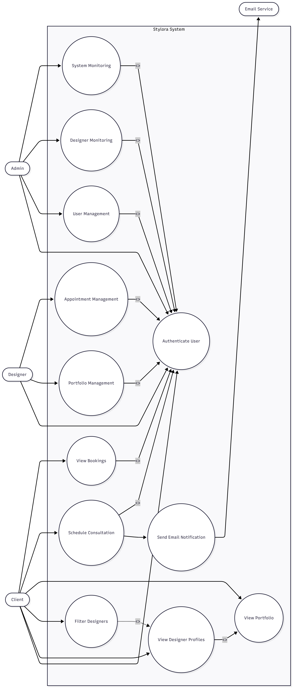

CLIENT (USER) USE CASES
Step 1 – User Registration / Login
Actor: Client
Use Case: Authenticate User
Steps:
- Client opens the Login / Register page.
- Client enters registration or login credentials.
- System validates the user credentials.
- If valid, the system authenticates the user.
- User session is created.
- Client gains access to platform features such as browsing designers and booking appointments.

Step 2 – Browse Designers
Actor: Client
Use Case: View Designer Profiles
Steps:
- Client visits the Home / Designer Listing page.
- System fetches designer profiles from the database.
- Designer portfolios are displayed.
- Client selects a designer profile.
- Detailed portfolio and project information are displayed.

Step 3 – Apply Search Filters
Actor: Client
Use Case: Filter Designers
Steps:
- Client applies filters such as design style, location, project type, or budget.
- System processes the filter request.
- Backend fetches matching designer profiles.
- Filtered designer results are displayed.
- Client selects a suitable designer.

Step 4 – View Designer Portfolio
Actor: Client
Use Case: View Portfolio
Steps:
- Client opens a designer’s profile.
- System fetches portfolio projects from database.
- Portfolio images and descriptions are displayed.
- Client reviews the designer’s work and design style.

Step 5 – Book Appointment
Actor: Client
Use Case: Schedule Consultation
Steps:
- Client clicks “Book Appointment”.
- Client selects date and time.
- System sends booking request to backend.
- Backend stores appointment details.
- Confirmation email is sent to both client and designer.

Step 6 – View Appointment History
Actor: Client
Use Case: View Bookings
Steps:
- Client opens Appointments Page.
- System fetches appointment history.
- Appointment details are displayed.


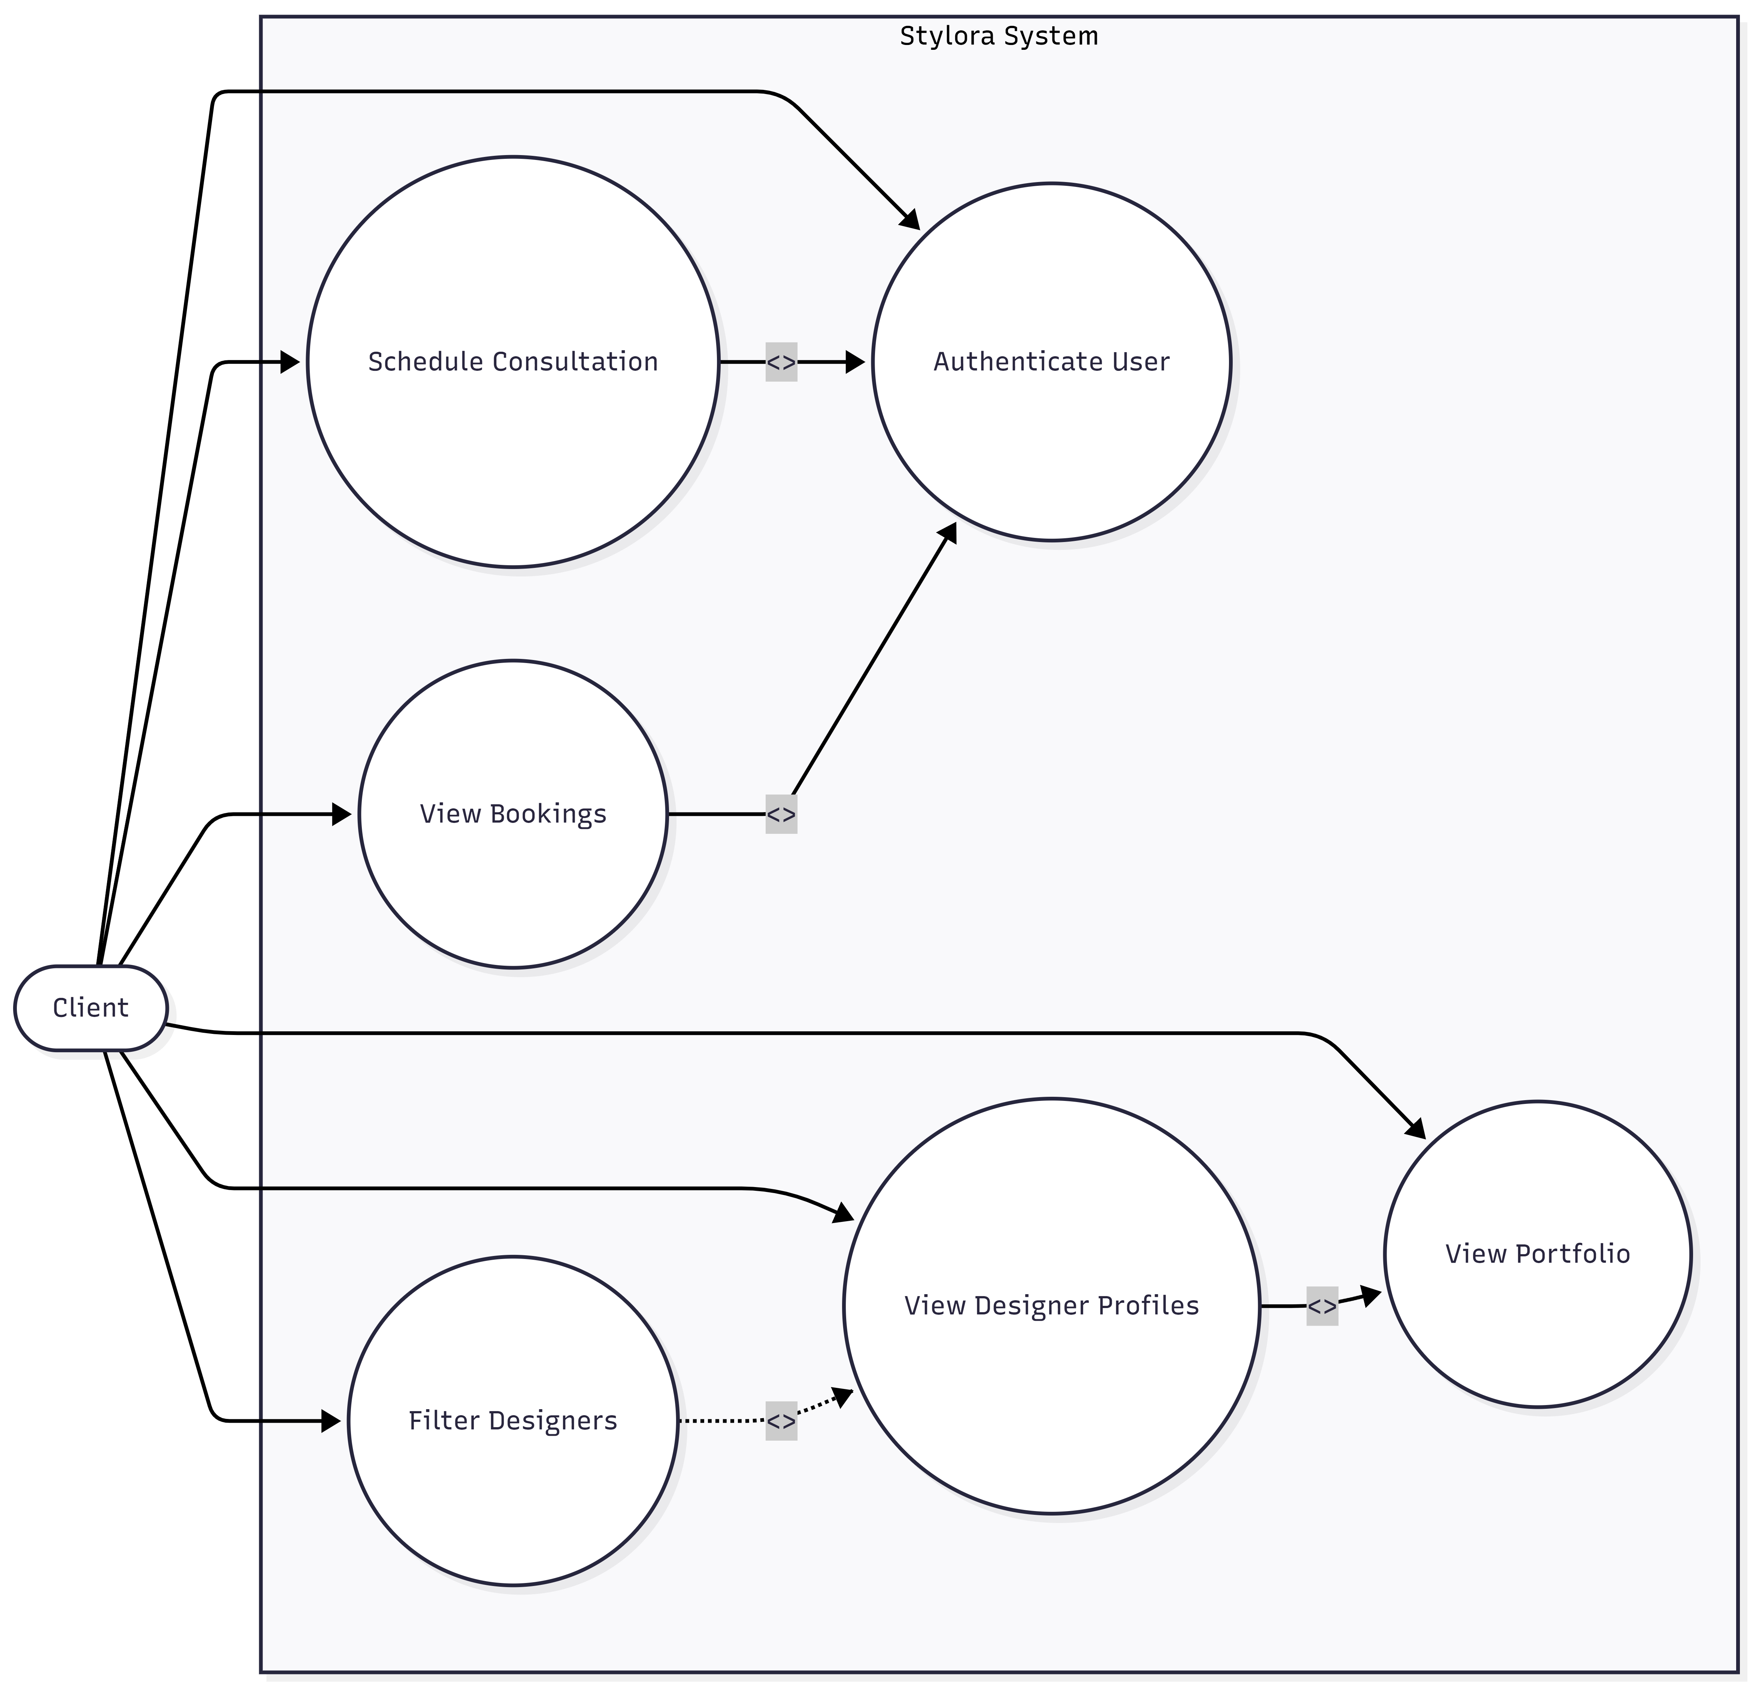

DESIGNER USE CASES
Step 1 – Designer Login
Actor: Designer
Use Case: Authenticate Designer
Steps:
- Designer logs into the platform.
- System verifies credentials.
- Designer gains access to the designer dashboard.

Step 2 – Manage Portfolio
Actor: Designer
Use Case: Portfolio Management
Steps:
- Designer uploads new project images.
- Designer adds project details and descriptions.
- Designer edits or deletes existing projects.
- Updated portfolio is saved in the database.

Step 3 – Manage Appointments
Actor: Designer
Use Case: Appointment Management
Steps:
- Designer views appointment requests.
- Designer confirms or manages consultation schedule.
- Appointment details are stored in the system.


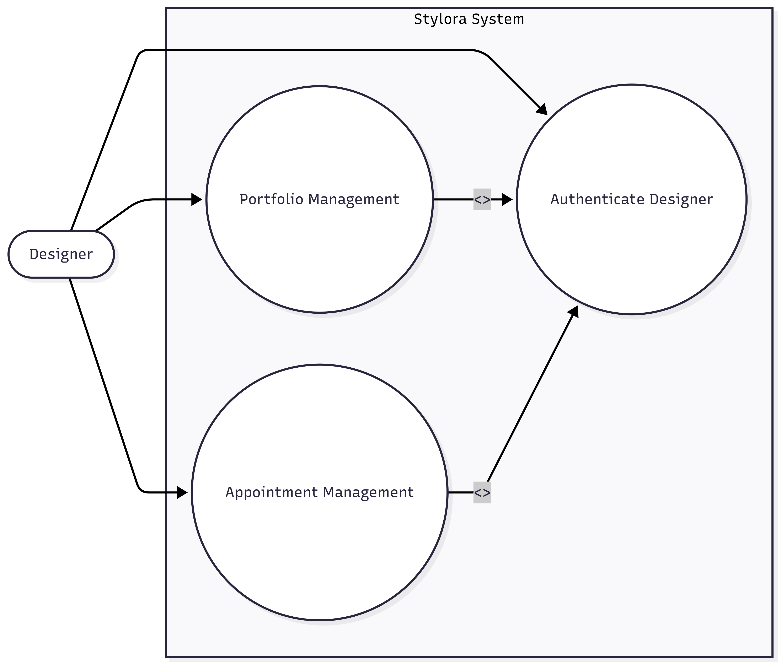

ADMIN USE CASES
Step 1 – Admin Login
Actor: Admin
Use Case: Authenticate Admin
Steps:
- Admin logs into the admin panel.
- System verifies credentials.
- Admin dashboard access is granted.

Step 2 – Manage Users
Actor: Admin
Use Case: User Management
Steps:
- Admin views all registered users.
- Admin can manage or remove accounts.
- System updates user records.

Step 3 – Monitor Designers
Actor: Admin
Use Case: Designer Monitoring
Steps:
- Admin views designer profiles.
- Admin monitors portfolios and activity.
- Admin manages categories or platform content.

Step 4 – Platform Monitoring
Actor: Admin
Use Case: System Monitoring
Steps:
- Admin views platform activity.
- Admin monitors appointments and user interactions.
- Admin ensures smooth system operation.


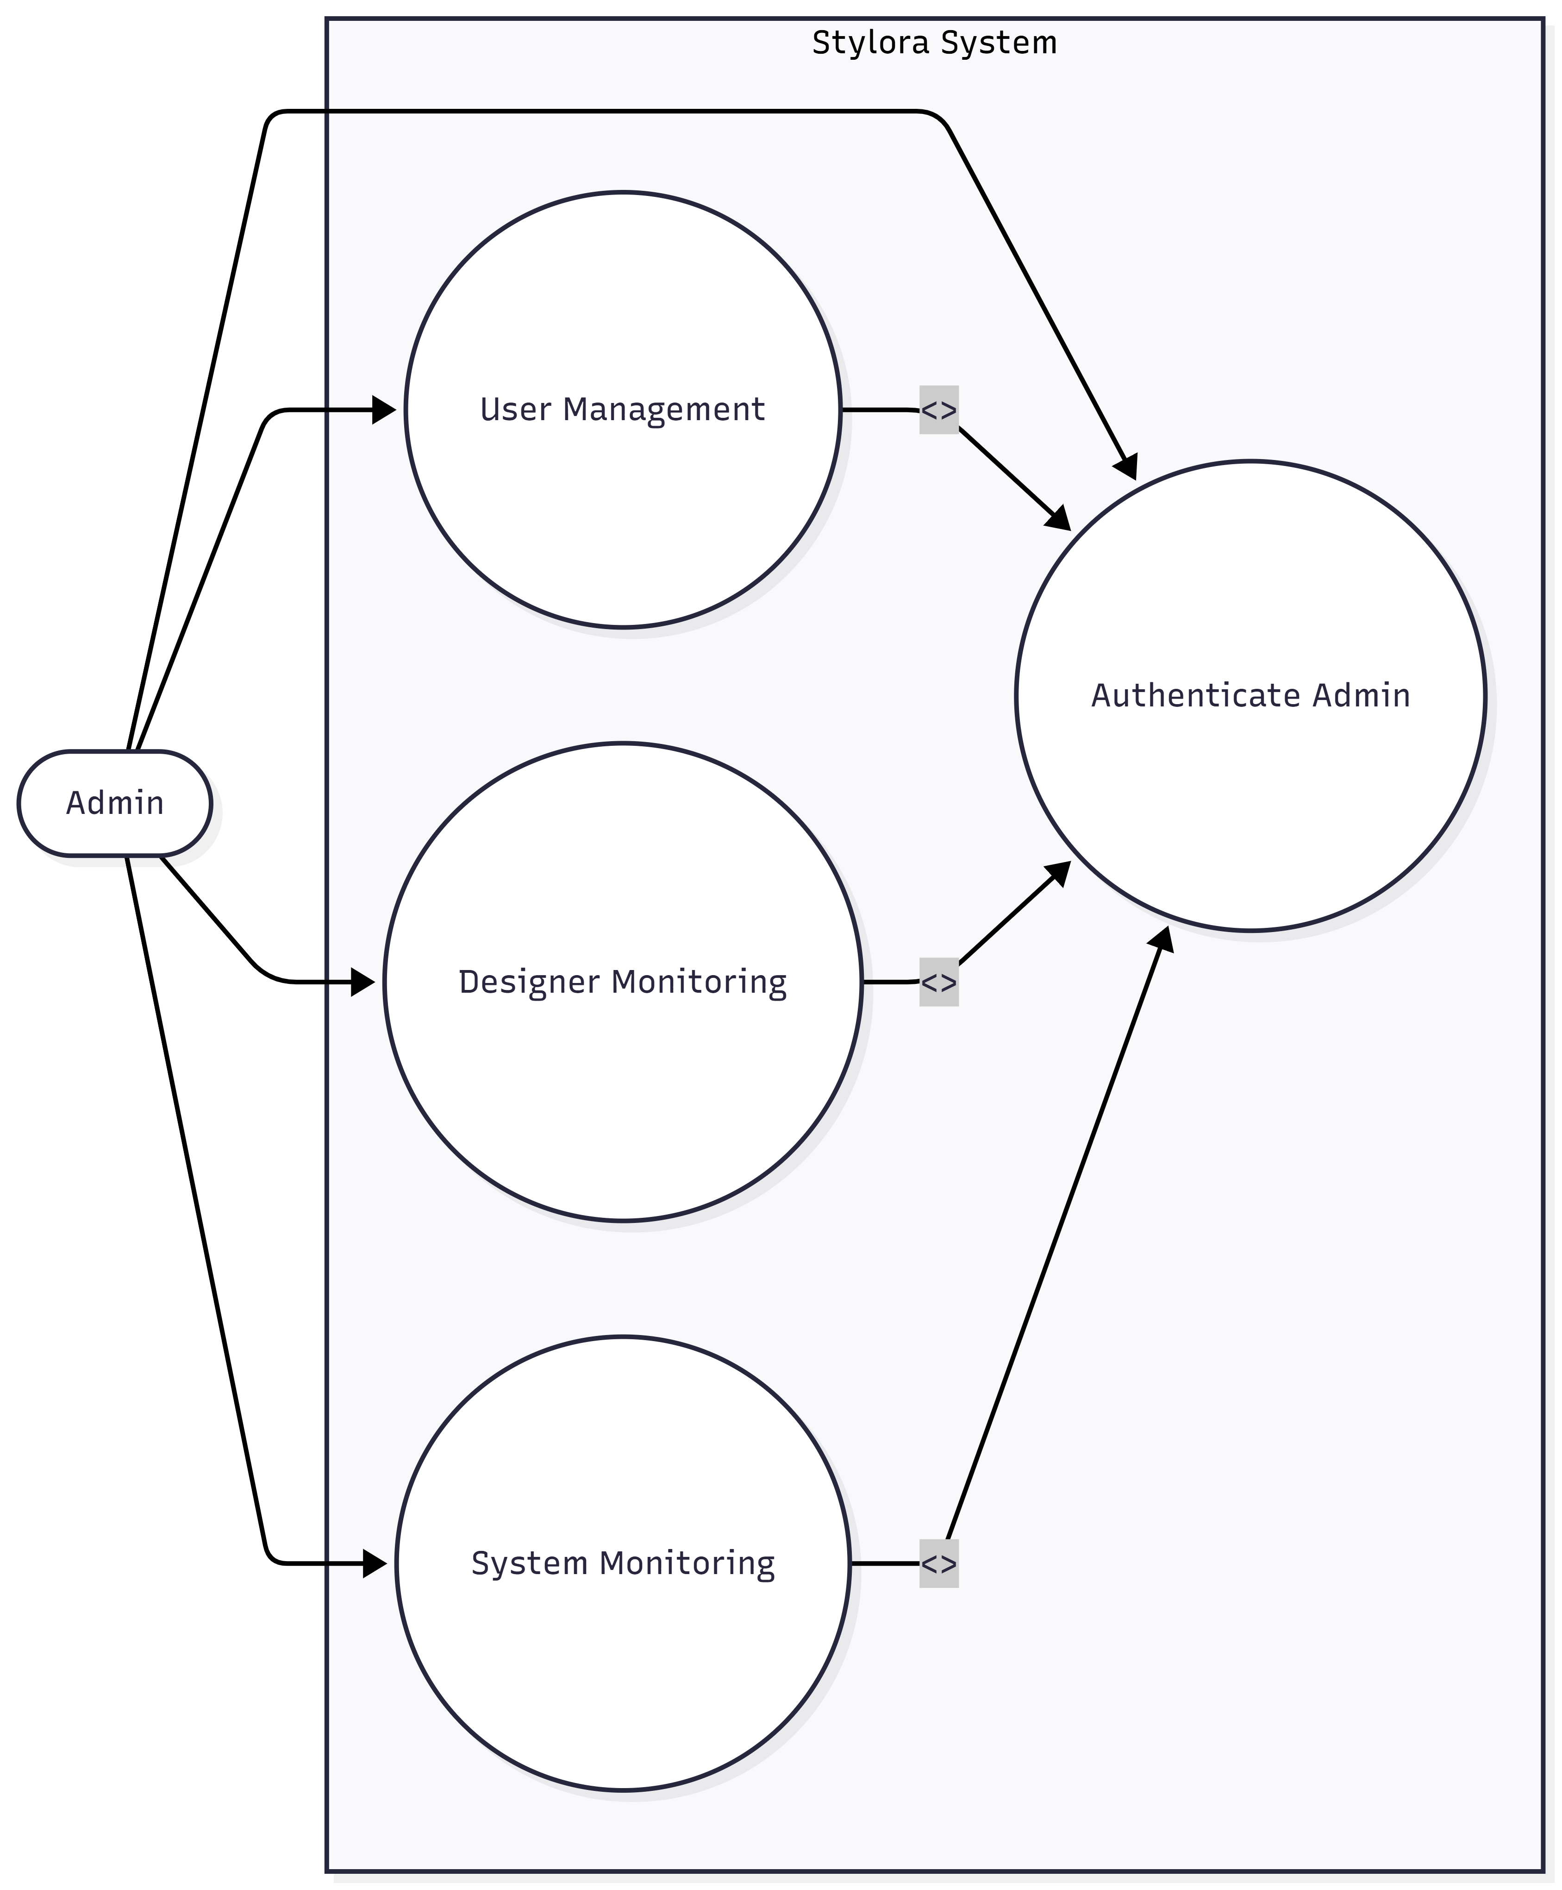

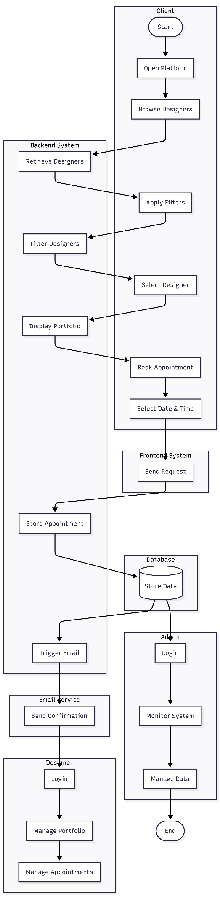
3.2 Activity Diagram

Activity Diagram – Client
Swimlanes
• Client
• Frontend System
• Backend System
• Email Service

Activity Flow
Step 1 – Start
- Start node.

Step 2 – Browse Designers
- Client opens website.
- Browse designer profiles.
- View portfolio details.

Step 3 – Apply Filters
- Apply search filters.
- System retrieves matching designers.

Step 4 – Appointment Booking
- Select designer.
- Click Book Appointment.
- Select consultation date and time.

Step 5 – Booking Processing
- Frontend sends appointment request.
- Backend stores booking details.

Step 6 – Email Notification
- Email service sends confirmation.
- Both designer and client receive notification.

Step 7 – End
- Appointment confirmed.
- End node.

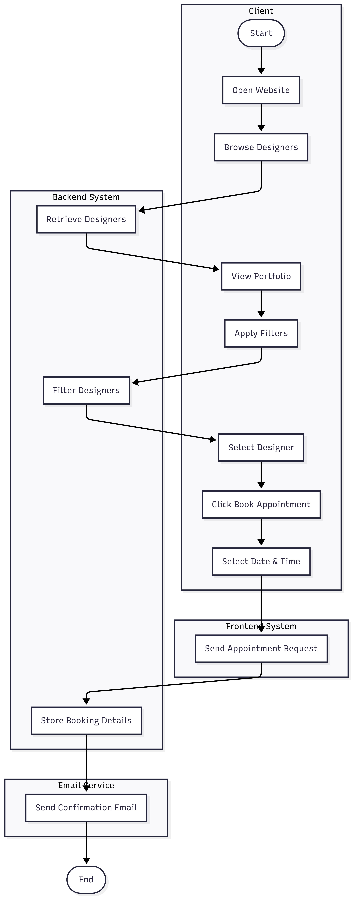

Activity Diagram – Designer
Swimlanes
- Designer
- Frontend System
- Backend System
- Database

Activity Flow
Step 1 – Start
- Start node.

Step 2 – Designer Login
- Designer opens login page.
- Designer enters credentials.
- Frontend sends login request.
- Backend validates credentials.
- Designer dashboard is displayed.

Step 3 – Manage Portfolio
- Designer navigates to portfolio section.
- Upload project images.
- Add project details and descriptions.
- Edit or delete existing projects.
- Frontend sends data to backend.
- Backend updates portfolio in database.

Step 4 – Manage Appointments
- Designer views appointment requests.
- Designer confirms or modifies schedule.
- Frontend sends update request.
- Backend updates appointment details.
- Database stores updated information.

Step 5 – End
- Updates saved successfully.
- End node.



Activity Diagram – Admin
Swimlanes
• Admin
• Admin Dashboard
• Backend System
• Database

Activity Flow
Step 1 – Start
- Start node.

Step 2 – Admin Authentication
- Admin logs in.
- System validates credentials.

Step 3 – Dashboard Monitoring
- Admin opens dashboard.
- Views users and designers.

Step 4 – Platform Management
- Manage designer profiles.
- Monitor platform activity.

Step 5 – Save Updates
- System updates database.

Step 6 – End
- End node.

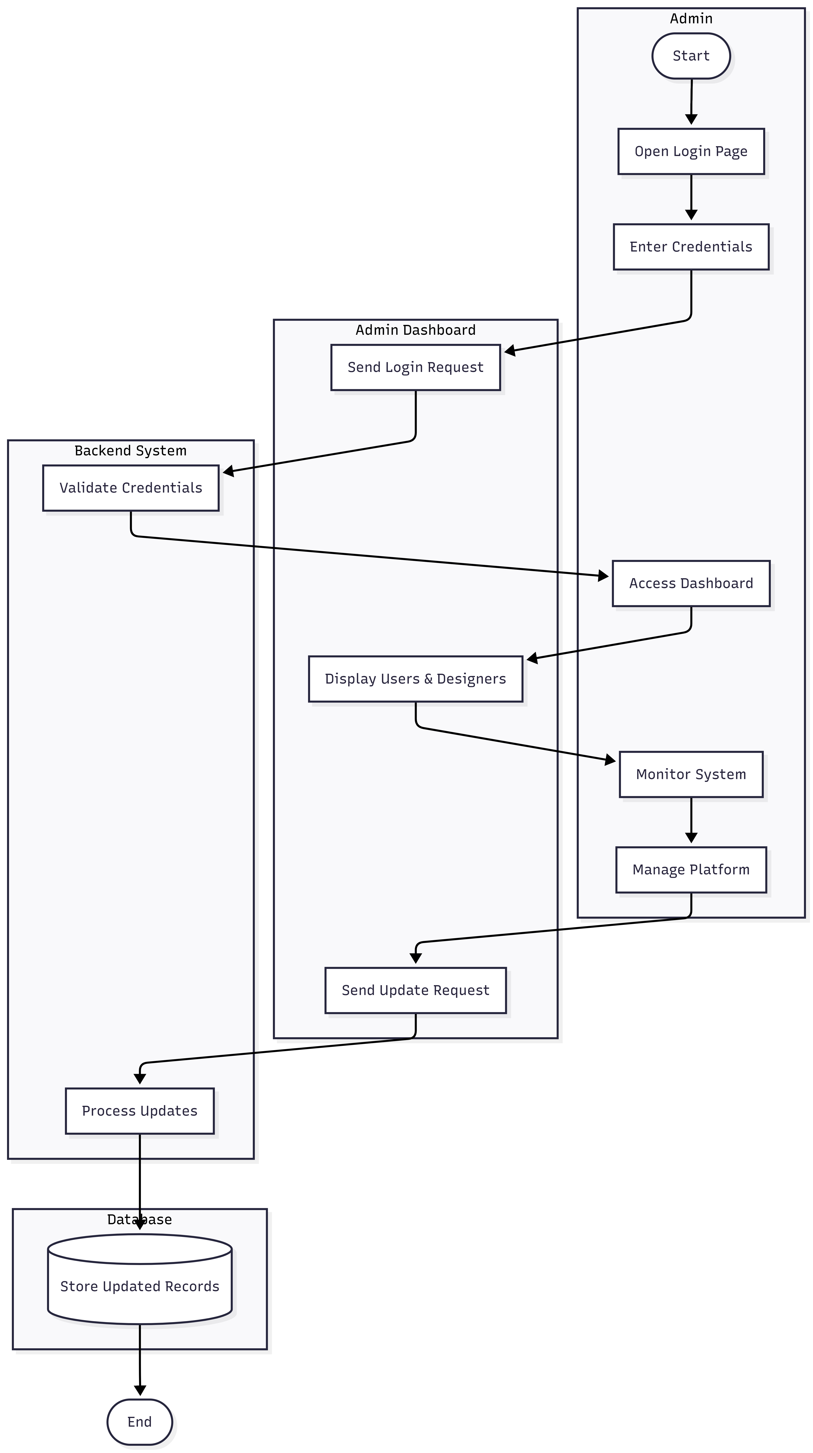
3.3 Sequence Diagram
1. Sequence Diagram – Client
Actors / Lifelines
- Client
- Frontend (UI)
- Backend Server
- Database
- Email Service

Sequence Steps: Book Appointment
Step 1 – Initiate Booking
- Client clicks “Book Appointment” on the UI.
- Frontend sends booking request to Backend Server.

Step 2 – Fetch Designer Information
- Backend Server requests designer details from Database.
- Database returns portfolio and designer data to Backend.

Step 3 – Create Appointment
- Backend stores appointment details in Database.
- Database confirms successful storage.

Step 4 – Send Email Notification
- Backend sends confirmation request to Email Service.
- Email Service sends confirmation to Client and Designer.

Step 5 – Completion
- Backend sends success response to Frontend.
- Frontend displays booking confirmation to Client.

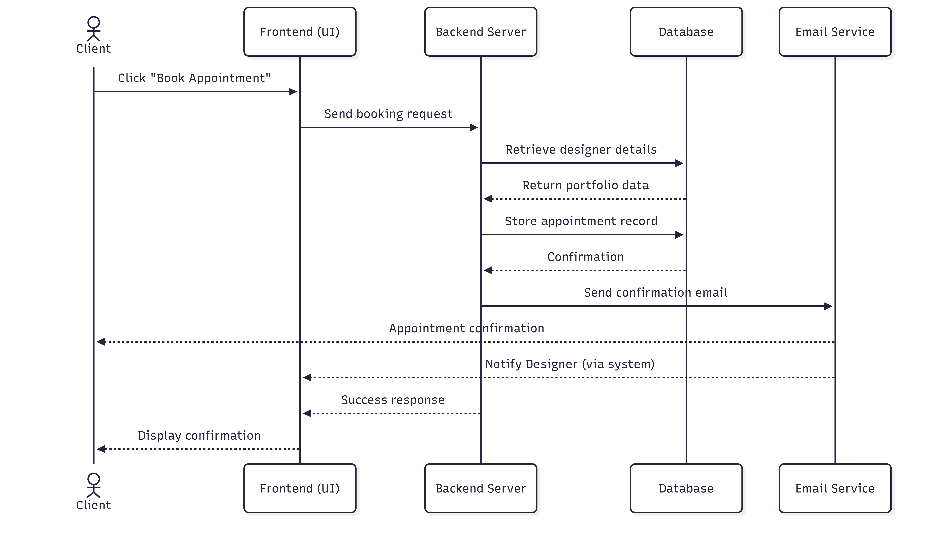

Sequence Diagram – Designer
Actors / Lifelines
- Designer
- Frontend (UI)
- Backend Server
- Database

Sequence Flow
Step 1 – Designer Login
- Designer enters login credentials through the UI.
- Frontend sends login request to Backend Server.
- Backend validates credentials with Database.
- Database returns validation result.
- Backend sends success response.
- Designer dashboard is displayed.

Step 2 – Manage Portfolio
- Designer uploads project images and details.
- Frontend sends portfolio data to Backend Server.
- Backend processes and stores portfolio data in Database.
- Database confirms storage.
- Backend sends success response to Frontend.
- Updated portfolio is displayed.

Step 3 – Manage Appointments
- Designer views appointment requests.
- Frontend requests appointment data from Backend.
- Backend retrieves appointment details from Database.
- Database returns appointment data.
- Backend sends data to Frontend.
- Designer confirms or updates appointment.
- Frontend sends update request to Backend.
- Backend updates appointment in Database.
- Database confirms update.

Step 4 – Completion
- Backend sends success response to Frontend.
- Frontend displays updated status to Designer.
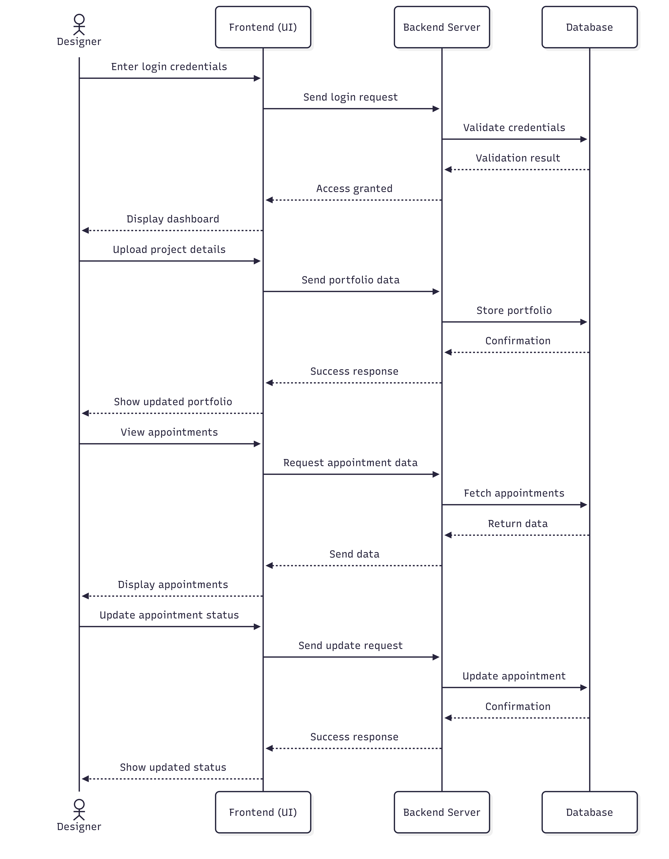

3 Sequence Diagram – Admin
Actors / Lifelines
- Admin
- Admin Interface
- Backend Server
- Database

1 Admin Login
- Admin logs in through the admin interface.
- Admin interface sends login request to backend.
- Backend verifies credentials.
- Admin dashboard is displayed.

2 Manage Designers
- Admin opens the designer management page.
- Backend retrieves designer profiles from the database.
- Designer data is displayed.

3 Monitor Platform
- Admin checks platform activity.
- Backend fetches system data.
- Database returns information.

4 Update Data
- Admin updates user or portfolio information.
- Backend updates records in the database.

5 Completion
- Admin operations completed successfully.
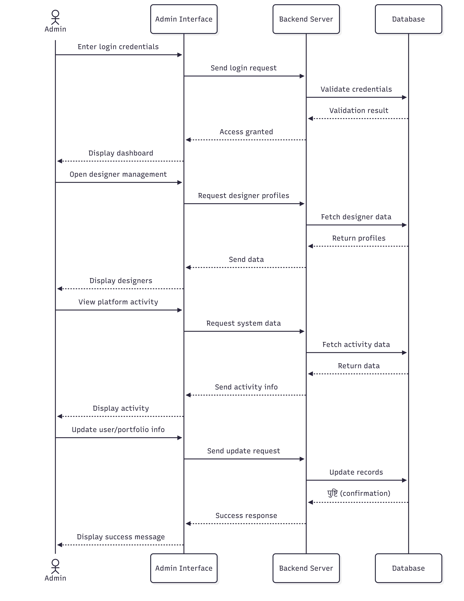

3.4 Class Diagram

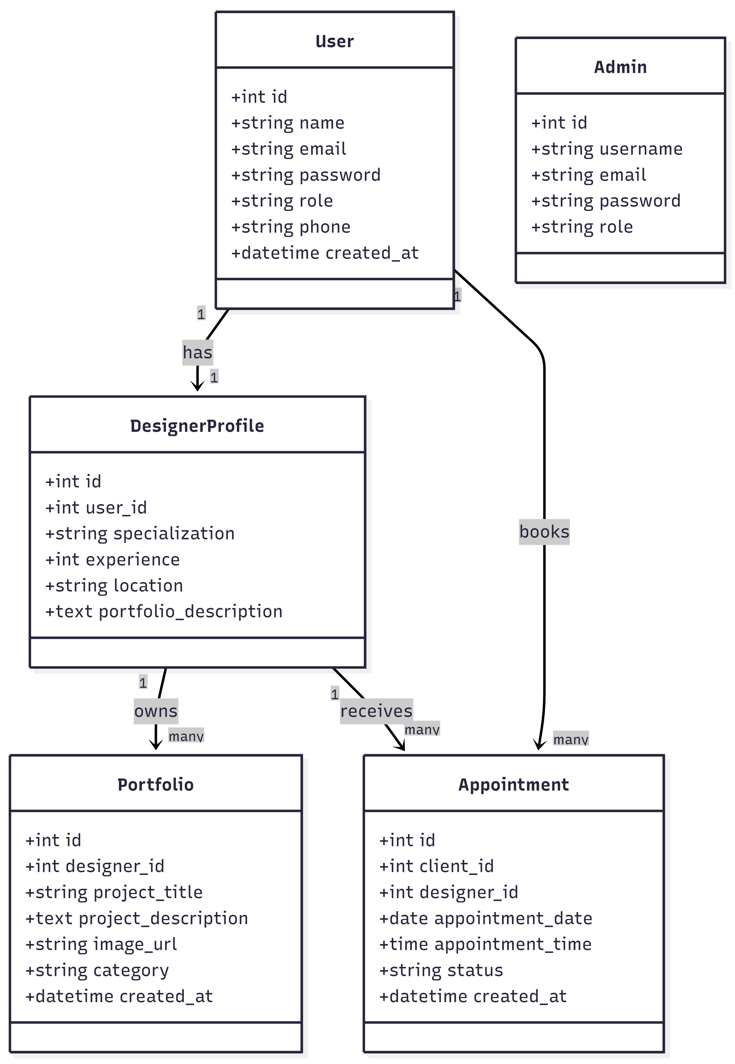

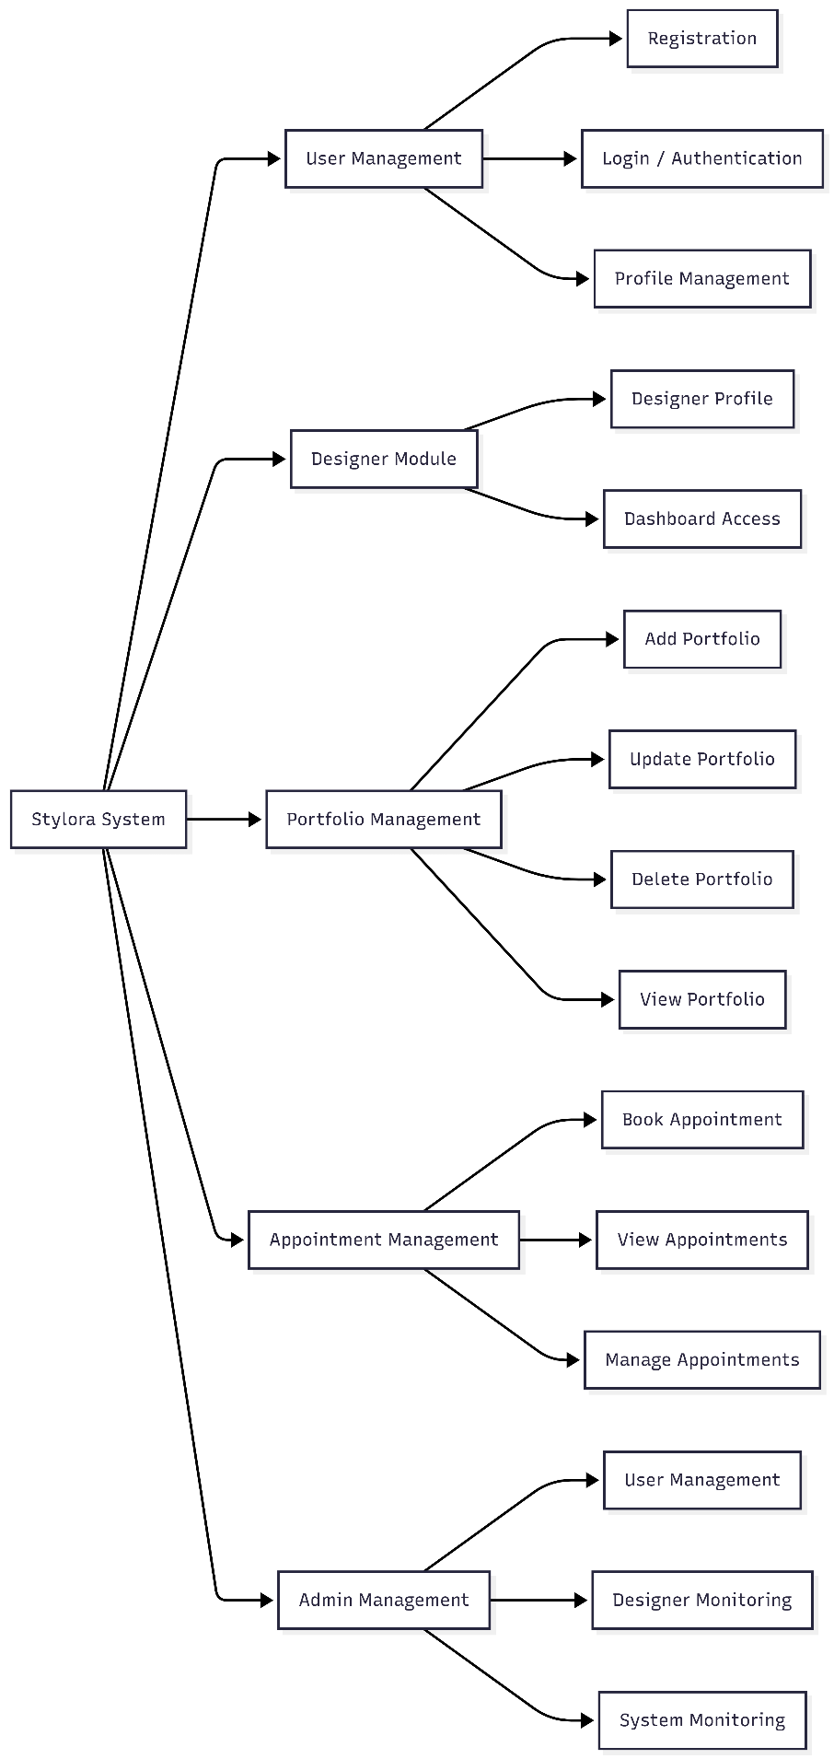
3.5 System Hierarchy Diagram

3.6 Table Specifications (Database Design)
Below is the Table Specification and Data Dictionary adapted for your Stylora project (Interior Designer Portfolio Platform). The structure is kept similar to your example format, but the tables reflect your actual system modules, such as Users, Designers, Portfolios, Appointments, and Admin.
1. User Table
Field | Type | Description
id | Integer | Primary Key
name | Varchar | Name of the user
email | Varchar | Unique email address
password | Varchar | Encrypted password
role | Varchar | User role (client/designer/admin)
phone | Varchar | Contact number
created_at | DateTime | Account creation date

2. Designer Profile Table
Field | Type | Description
id | Integer | Primary Key
user_id | Integer | Foreign Key referencing User
specialization | Varchar | Designer specialization
experience | Integer | Years of experience
location | Varchar | Designer location
portfolio_description | Text | Designer introduction

3. Portfolio Table
Field | Type | Description
id | Integer | Primary Key
designer_id | Integer | Foreign Key referencing Designer
project_title | Varchar | Title of the project
project_description | Text | Description of design project
image_url | Varchar | Project image path
category | Varchar | Type of design (modern, minimal, luxury)
created_at | DateTime | Date of project upload

4. Appointment Table
Field | Type | Description
id | Integer | Primary Key
client_id | Integer | Foreign Key referencing User
designer_id | Integer | Foreign Key referencing Designer
appointment_date | Date | Consultation date
appointment_time | Time | Consultation time
status | Varchar | Appointment status (pending/confirmed/cancelled)
created_at | DateTime | Booking timestamp

5. Admin Table
Field | Type | Description
id | Integer | Primary Key
username | Varchar | Admin username
email | Varchar | Admin email
password | Varchar | Encrypted password
role | Varchar | Admin role

3.8 Data Dictionary
Field Name | Data Type | Constraints | Table Name
id | Integer | Primary Key, Auto Increment | User
name | Varchar | Required | User
email | Varchar | Unique, Required | User
password | Varchar | Required, Encrypted | User
role | Varchar | Enum (client, designer, admin) | User
phone | Varchar | Optional | User
created_at | DateTime | Auto generated | User
id | Integer | Primary Key | Designer_Profile
user_id | Integer | Foreign Key → User | Designer_Profile
specialization | Varchar | Optional | Designer_Profile
experience | Integer | Optional | Designer_Profile
location | Varchar | Optional | Designer_Profile
portfolio_description | Text | Optional | Designer_Profile
id | Integer | Primary Key | Portfolio
designer_id | Integer | Foreign Key → Designer_Profile | Portfolio
project_title | Varchar | Required | Portfolio
project_description | Text | Required | Portfolio
image_url | Varchar | Required | Portfolio
category | Varchar | Optional | Portfolio
created_at | DateTime | Auto generated | Portfolio
id | Integer | Primary Key | Appointment
client_id | Integer | Foreign Key → User | Appointment
designer_id | Integer | Foreign Key → Designer_Profile | Appointment
appointment_date | Date | Required | Appointment
appointment_time | Time | Required | Appointment
status | Varchar | Enum (pending, confirmed, cancelled) | Appointment
created_at | DateTime | Auto generated | Appointment
id | Integer | Primary Key | Admin
username | Varchar | Required | Admin
email | Varchar | Unique | Admin
password | Varchar | Required, Encrypted | Admin
role | Varchar | Enum (admin) | Admin

CHAPTER 4: USER MANUAL
4.1 User Interface Screens (Input)
4.2 Output Screens with data
4.3 Data Reports
4.4 Sample program code
4.5 Limitations
Despite the effective functionality and structured design of the Stylora system, there are certain limitations that may impact user experience, scalability, and overall system performance. These limitations highlight areas for future improvement and enhancement.

1. Dependence on Internet Connectivity
Stylora is a fully web-based application that requires a stable and continuous internet connection. Users in areas with poor network connectivity may experience delays in loading pages, difficulty in accessing portfolios, or failure in booking appointments. This dependency reduces accessibility for users with limited internet resources.

2. Lack of Real-Time Communication Features
The system primarily relies on appointment booking and email notifications for communication between clients and designers. There is no provision for real-time chat or instant messaging. This limitation may lead to delays in communication, especially when users require immediate clarification or discussion before booking a consultation.

3. Limited Personalization and Recommendation System
The platform provides basic filter-based search functionality; however, it lacks advanced personalization features such as AI-based recommendations. The system does not analyze user preferences, browsing history, or past interactions to suggest suitable designers, which may reduce efficiency in decision-making.

4. Absence of Integrated Payment Gateway
Currently, Stylora does not support online payment integration for booking consultations or services. Users must rely on external payment methods outside the platform, which may reduce convenience and trust. The absence of secure payment handling also limits the platform’s ability to provide a complete end-to-end service experience.

5. Limited Portfolio Interaction and Feedback Mechanism
While designers can showcase their work through portfolios, the system does not include interactive features such as ratings, reviews, or comments. This prevents clients from evaluating designers based on feedback from other users and reduces engagement within the platform.

6. Scalability and Performance Constraints
As the number of users, designers, and portfolio data increases, system performance may degrade if not optimized properly. The current system may face challenges in handling high traffic, large data volumes, and concurrent user requests without additional infrastructure support such as load balancing and database optimization.

7. Basic Security Implementation
Although the system implements authentication and role-based access control, advanced security mechanisms such as multi-factor authentication, data encryption, and protection against cyber threats (e.g., SQL injection, cross-site scripting) may not be fully implemented. This could pose potential risks in real-world deployment.

8. No Dedicated Mobile Application
Stylora is currently available only as a web application. While it may support responsive design, the absence of a dedicated mobile application can limit user experience, performance, and accessibility on smartphones and tablets.

9. Dependency on External Email Services
The system relies on third-party email services to send appointment confirmations and notifications. Any delay, failure, or downtime in these external services can impact communication between users and reduce system reliability.

10. Limited Administrative Automation
Administrative functionalities such as user monitoring, portfolio management, and system control are performed manually through the admin dashboard. The lack of automated moderation tools, analytics, and reporting systems increases the workload on administrators and may reduce operational efficiency.

11. No Offline Functionality
The system does not support offline access or caching mechanisms. Users cannot access previously viewed data or perform actions without an active internet connection, which limits usability in low-connectivity environments.

12. Limited Integration with External Platforms
Stylora does not currently integrate with external platforms such as social media, design tools, or third-party APIs. This restricts the ability to enhance user experience through features like social sharing, external portfolio imports, or cross-platform visibility.

Bibliography
The following references were used for understanding concepts, technologies, and tools applied in the development of the Stylora system.

Books
- Pressman, Roger S.
Software Engineering: A Practitioner’s Approach, McGraw-Hill Education.
- Sommerville, Ian.
Software Engineering, Pearson Education.
- Elmasri, Ramez and Navathe, Shamkant B.
Fundamentals of Database Systems, Pearson.

Web References
- Mozilla Developer Network
https://developer.mozilla.org
(Reference for HTML, CSS, and JavaScript concepts)
- React Official Documentation
https://react.dev
(Used for frontend development concepts)
- Node.js Official Documentation
https://nodejs.org
(Backend runtime environment reference)
- Express.js Official Documentation
https://expressjs.com
(Used for building REST APIs)
- MongoDB Documentation
https://www.mongodb.com/docs
(Database design and queries)
- W3Schools
https://www.w3schools.com
(Basic reference for web technologies)
- GeeksforGeeks
https://www.geeksforgeeks.org
(Conceptual understanding and examples)

